

Year PreATAR 10 Science

**Physics 1 Test: Motion**

**SECTION 1: MULTIPLE CHOICE** (1 mark each)

Circle your answer on the multiple choice answer sheet.

1. Displacement is
2. the same as distance travelled.
3. the straight-line distance between two places.
4. the straight-line distance and direction between two points.
5. how fast something is travelling.
6. A heavy vehicle is slower to accelerate and harder to stop than a light vehicle. This is because of
   1. inertia.
   2. velocity.
   3. impact.
   4. gravity.

The next three questions refer to the following diagram

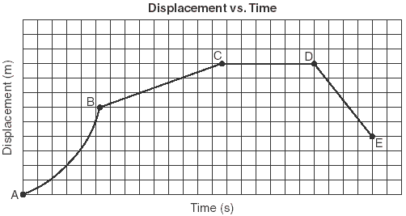

1. The motion between A and B would be described as
   1. constant speed
   2. constant velocity
   3. acceleration
   4. deceleration
2. The distance travelled between C and D is

a) 0 m

b) approximately 6

c) approximately 9 m

d) unable to be determined from this information

1. From D to E the object would be

a) accelerating

b) decelerating

c) travelling forwards at constant velocity

d) travelling backwards at constant velocity

1. Which of these is not an example of a force?
   1. push
   2. pull
   3. twist
   4. heat
2. Which of the following is not an effect of a force?
3. changing the speed of an object
4. changing the direction of an object’s motion
5. changing the size of an object
6. changing the shape of an object
7. Study the diagram below that shows the forces involved in an aeroplane.

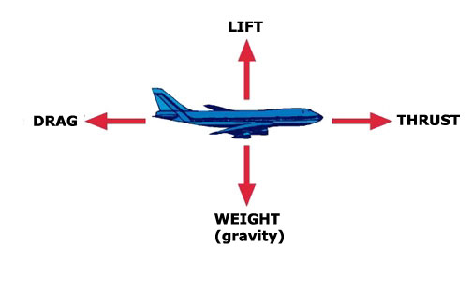

If the aeroplane is travelling forwards at constant velocity and at constant altitude (height) which statement is correct about the forces involved.

1. The drag and the thrust are unbalanced.
2. The weight and the lift are unbalanced.
3. The drag and the thrust are balanced.
4. All the forces are balanced.
5. Which statement is correct about the forces shown in the diagram below?

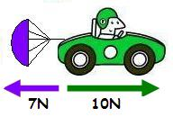

1. The resultant force is 17N.
2. The car will decelerate (slow down).
3. The car will accelerate (speed up).
4. The car will travel at constant speed.

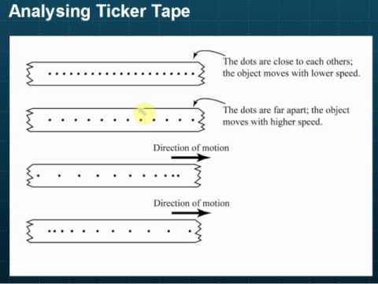

1. The ticker tape shows
   1. acceleration
   2. constant velocity
   3. negative acceleration (deceleration)
   4. an object at rest

**SECTION 2: WRITTEN**

**Write all answers in the spaces provided. Show working. If you need more space, ask for some lined paper**

Formulae you might need:

F = m x a v = u +at Ep= mxgxh There are 1000 m in a km.

Vav = s Wt = m x g Ek= ½ m v2 There are 3600 s in an hr.

t

a = v-u g = 9.8 m s-2

t

**ɳ= useful output x 100**

**input**

**Ep= mgh Ek= ½ mv2**

1. A car was involved in a time trial. The car started from rest and accelerated as quickly as possible over the straight course of 500m. It took 25 seconds to complete this distance. Determine the average speed of the car during the time trial. (2)
2. A parachutist is falling with a constant speed of 7 ms-1. Calculate how long it will take to reach the ground 1200m below. (3)
3. Indicate the direction and size of the resultant force for each of the following: (3)

a) 5N b) 40N c) 100N

7N 50N 60N

1. a) A car, initially travelling at 15 ms-1, accelerates at 2 ms-2 for 4 seconds. Determine its final velocity. (3)

b) If its mass is 1600 kg, determine the force that would need to be put into accelerating it. (2)

1. A roller coaster with mass 2000 kg falls from a height of 26 m. At the bottom of the fall, its velocity is 7 ms-1. Determine the efficiency of the energy transfer from potential to kinetic.

(3)

End of Test /26